The THINKIUM “DEVELOPER BOUNTY PLAN”

I’m a proud Thinkium benefactor, I'd like to introduce the "Thinkium developer plan" to the developers out there. I'll give an overview of Thinkium's node installation methods in JavaScript.

INTRODUCTION

Because Thinkium is compatible with Ethereum's development interface, it can use the Ethereum SDK for chain development directly.

•Ethereum SDK docs:

<https://ethereum.org/zh/developers/docs/programming-languages/>

Download the official Thinkium SDK if you wish to undertake cross-chain development. JS, Java, Go, and Python are the four language versions we now offer.

It is advised that you get the SDK for the respective language for specific usage. The SDK includes thorough test scenarios.

•Java SDK address:

<https://github.com/ThinkiumGroup/web3j>

•JS SDK address:

<https://github.com/ThinkiumGroup/web3.js>

•Go SDK address:

<https://github.com/ThinkiumGroup/web3.go>

THE MOST IMPORTANT ADDRESS AND GENERATION

JS has a mnemonic, private key, public key, and address generation method that app-side developers can use.

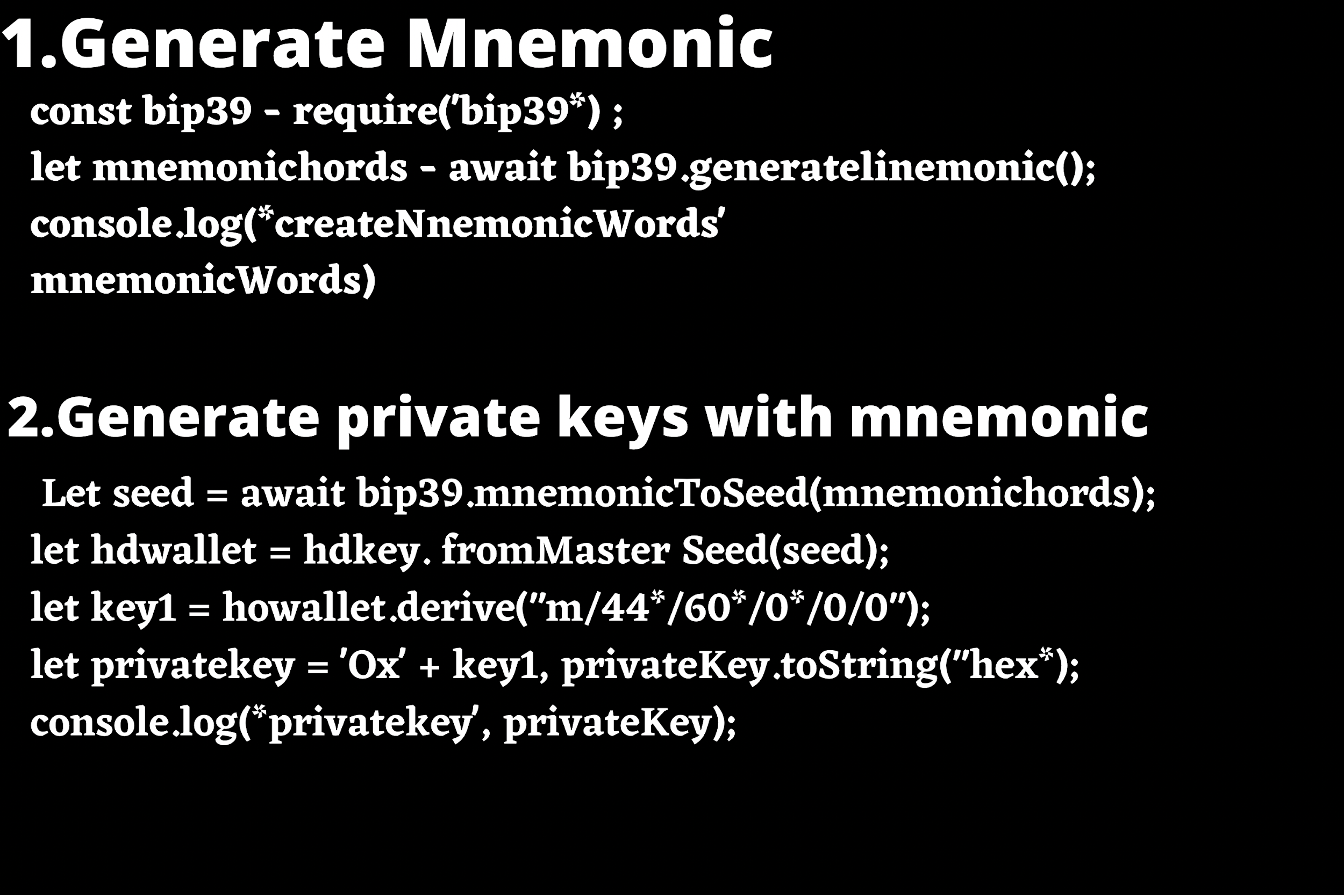

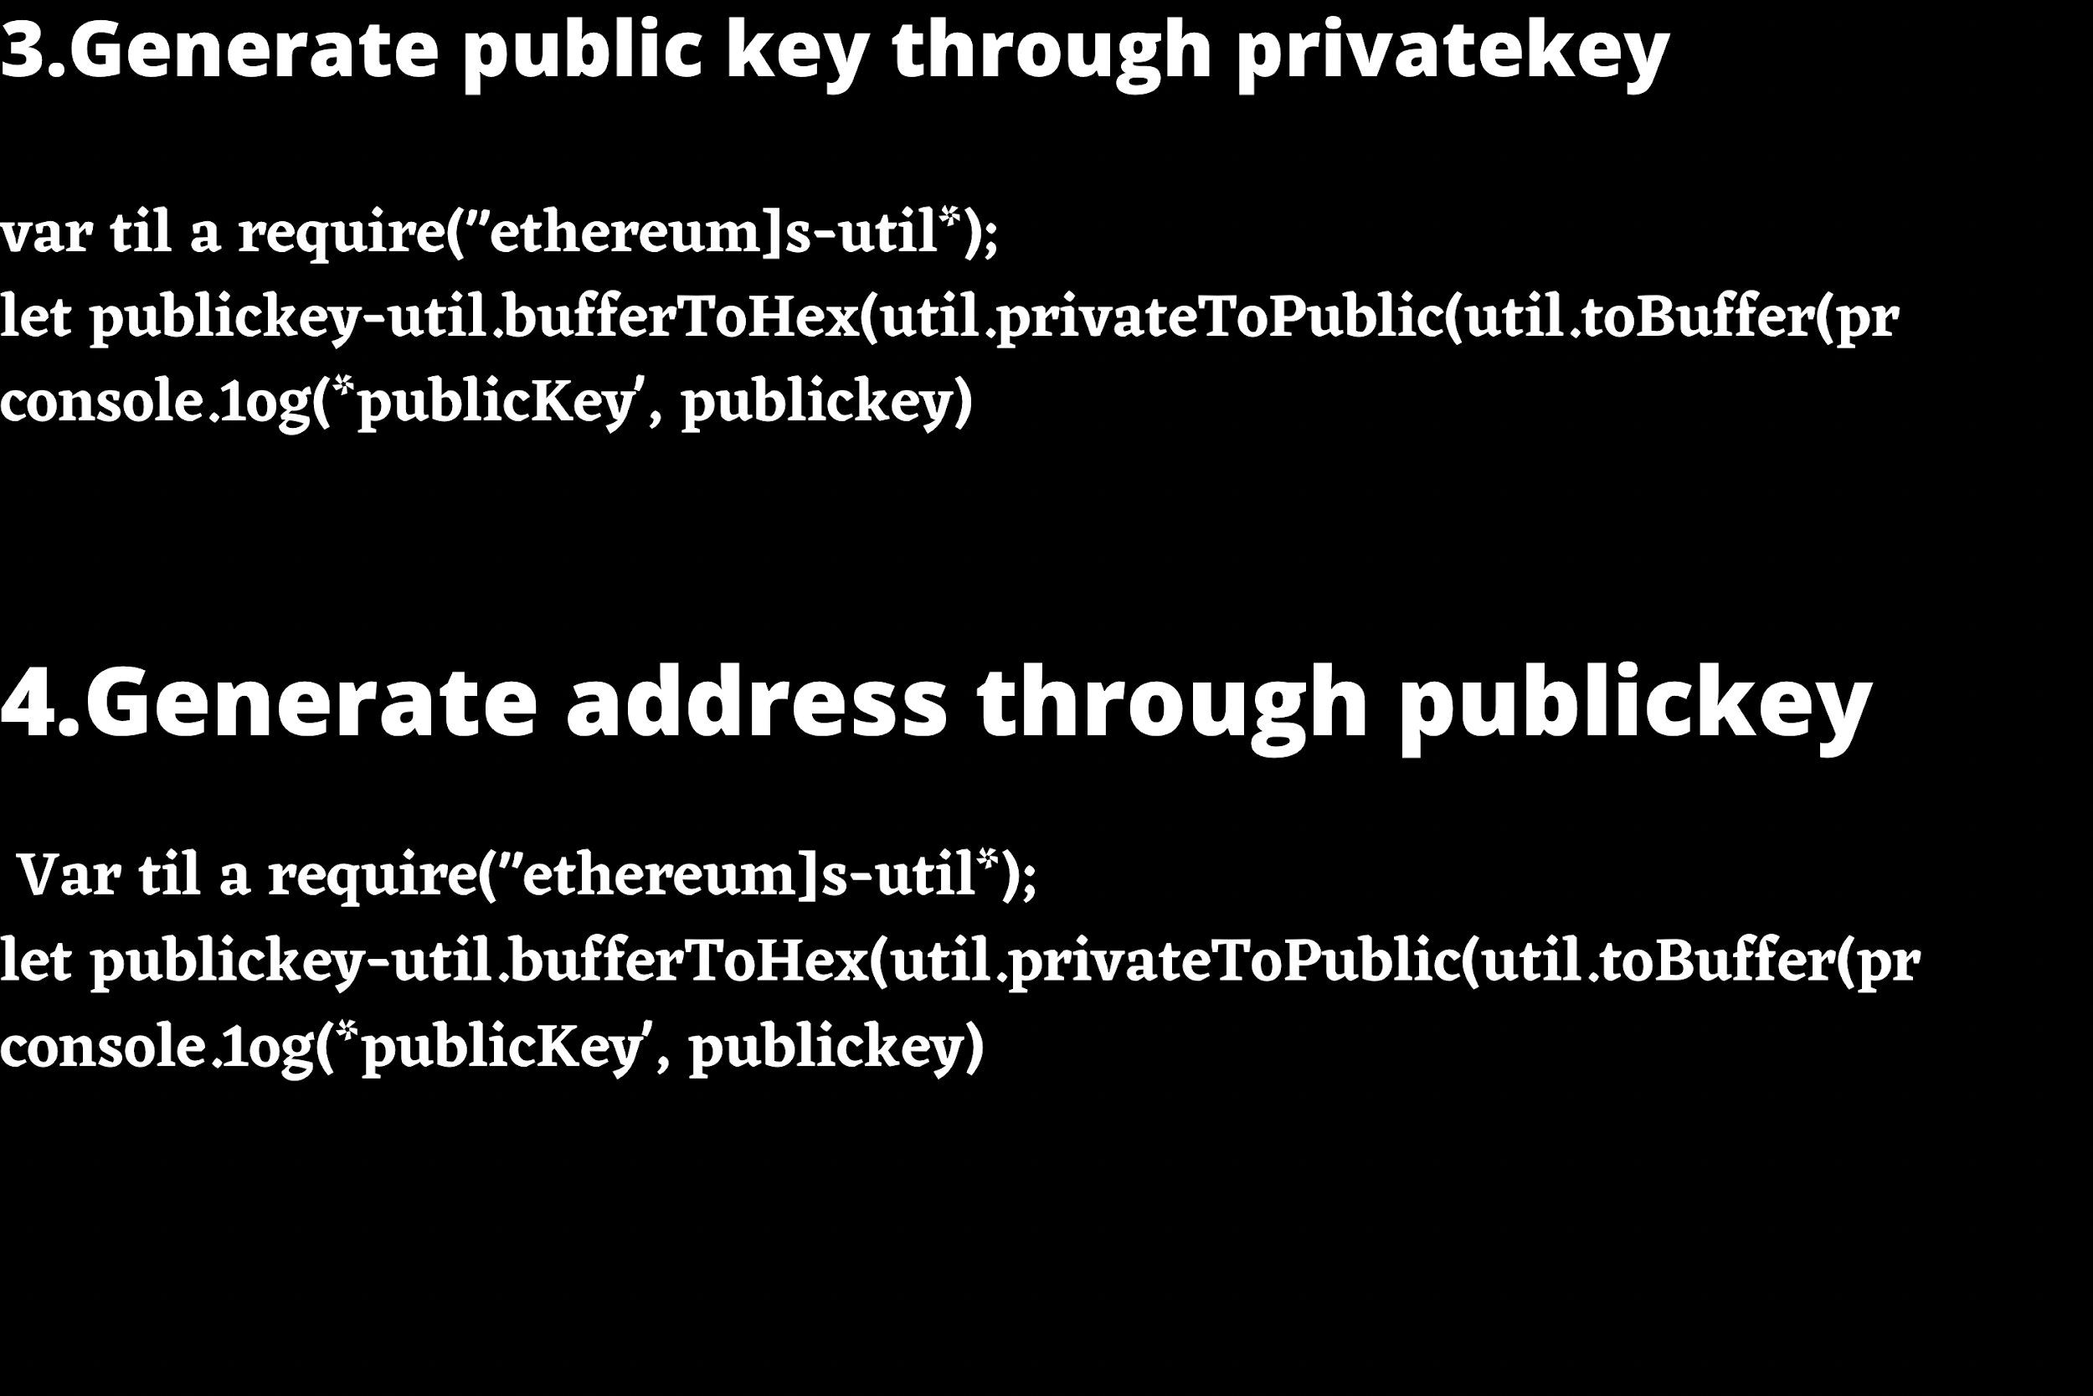

ADDRESS BEAUTIFICATION

TH to 0x address conversion. The address conversion function is now available on the JS side.

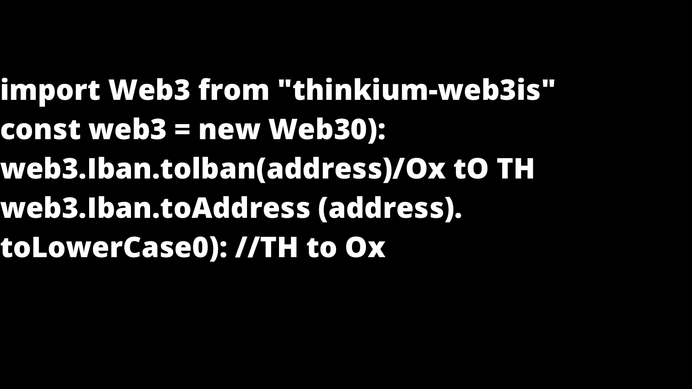

____________________________________________

JAVASCRIPT

GITHUB

URL ADDRESS: <https://github.com/ThinkiumGroup/web3.js>

MODULE

In your html file, include web3.min.js. (This isn't required for the meteor package to work)

USUAGE

You can use the web3 object straight from the ;

•global namespace

•set provider

____________________________________________

CHAIN API

1.Get account: info(web3.thk.GetAccount)

2.send transaction :(web3.thk.SendTx)

3.get transaction info by hash

(web3.thk.GetTransactionByHash)

4.Get chain information (web3.thk.GetStats)

5.Get transaction information of the specified account within a certain height range on the chain (web3.thk.GetTransactions)

#thinkium #blockchain #cryptocurrnecy #developerbountyprogram